Vacuum Cleaner  (Retirement Report) |  | Badran ID | O-00129-16
 |  | Description | Acer Laptop
 |  | Location | HEAD OFFICE
 |  | Department | Akrat – 200
 |  | Custodian | J013.6 (Ajin M. Manonmony)
Material Picture | 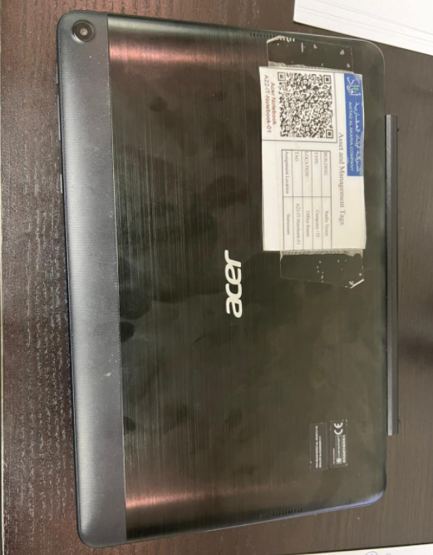
Symptoms | As Per the Picture for the Acer laptop is not working
Reasons | Motherboard is damage
Solution | Need to do the retirement.

Prepared By | Confirmed By | Approved By
614  Mojahid Hussain | 610  Russel. M. Kamarudeen | 600  Abdulrahman Y. Alshaikh

