HP LaserJet M225 Printer  (Retirement Report) |  | Badran ID
 |  | Description
 |  | Location | HEAD OFFICE
 |  | Department | HR
 |  | Custodian
Material Picture | 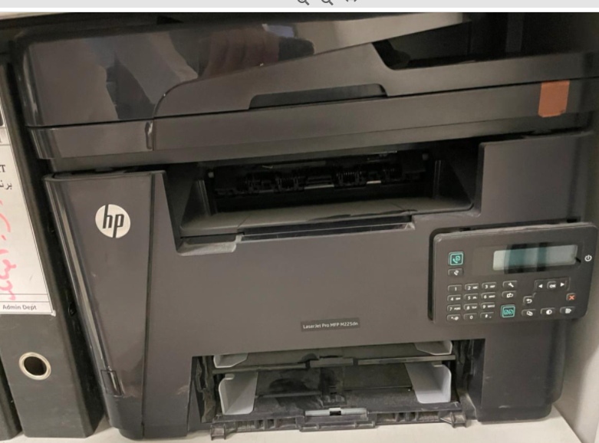
Symptoms | Below pictured HP laser M225 printer is Damage at Head Office.
Reasons | Printer is damage and mother bord cannot be repaired
Solution | Material is very old , and it to be retired

Prepared By | Confirmed By | Approved By
614  Mojahid Hussain | 610  Russel. M. Kamarudeen | 600  Abdulrahman Y. Alshaikh

