Dell OptiPlex 755 PC  (Retirement Report) |  | Badran ID | COMP-00033_3
 |  | Description | كمبيوتر دل اوبتيبلكس 780 كور2دو
 |  | Location | HEAD OFFICE
 |  | Department | ACCOUNTS
 |  | Custodian | J001-35 – SAM AYTONA REYES
Material Picture | 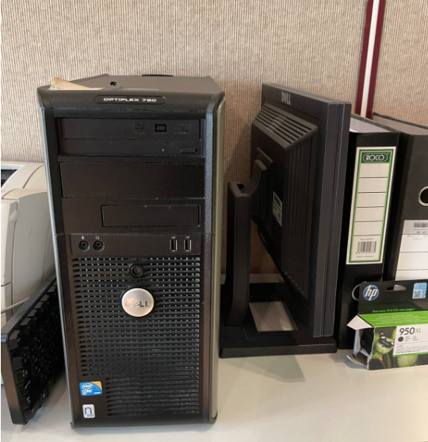
Symptoms | Above pictured PC (Dell OptiPlex) at Accounts Department not working since long time.
Reasons | 1: (Dell System 755) is very old PC and motherboard has been damaged, and not able to repair because the material is out of stock and not available in Market.
Solution | Need to do the retirement.

Prepared By | Confirmed By | Approved By
614  Mojahid Hussain | 610  Russel. M. Kamarudeen | 600  Abdulrahman Y. Alshaikh

