614 –Mohammad Mojahid Hussain  | June 16, 2021

110 Printer Report

Printer

Prepared By

**614-Mojahid Hussain**

Checked

**610 - Russel. M. Kamarudeen**

Approved By

**Abdulrahman Y. Alshaikh**

**Symptoms:** As Per below Picture HP Printer is damage

**Reasons:**

There is the issue with Motherboard and cannot be repaired due to old stock

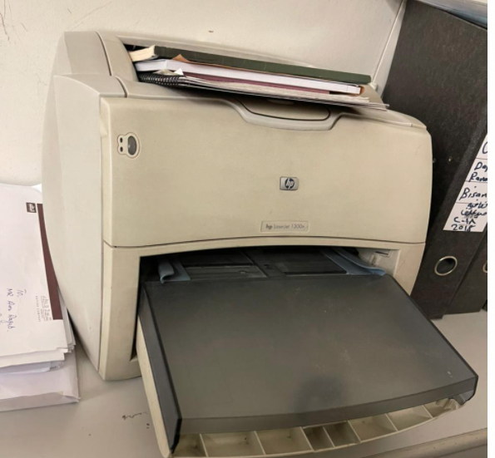

**Solution:** This printer is old and as per the Printer technical cannot replace the motherboard.