Genx Scanner  (Retirement Report) |  | Badran ID | O-00013-25
 |  | Description | GenX Scanner with USB, SN 571J8C050454
 |  | Location | HEAD OFFICE
 |  | Department | ACCOUNTS
 |  | Custodian | J001-35 – SAM AYTONA REYES
Material Picture | 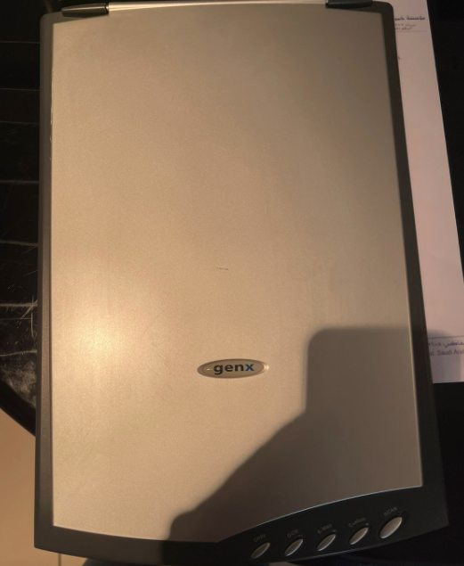
Symptoms | As Per the Picture for the Genx Scanner is very old and board damaged
Reasons | Very old scanner and issue is the Dram cannot be repaired.
Solution | Need to do the retirement.

Prepared By | Confirmed By | Approved By
614  Mojahid Hussain | 610  Russel. M. Kamarudeen | 600  Abdulrahman Y. Alshaikh

