614 –Mohammad Mojahid Hussain  | August 12, 2021

**HP Laser Printer M225**

How to SLOVE Fuser Unit

Prepared By

**614-Mojahid Hussain**

Checked

**610 - Russel. M. Kamarudeen**

Approved By

**600 - Abdulrahman Y. Alshaikh**

**Symptoms:** as per below picture for HP laser M225 Fuser Unit is damage.

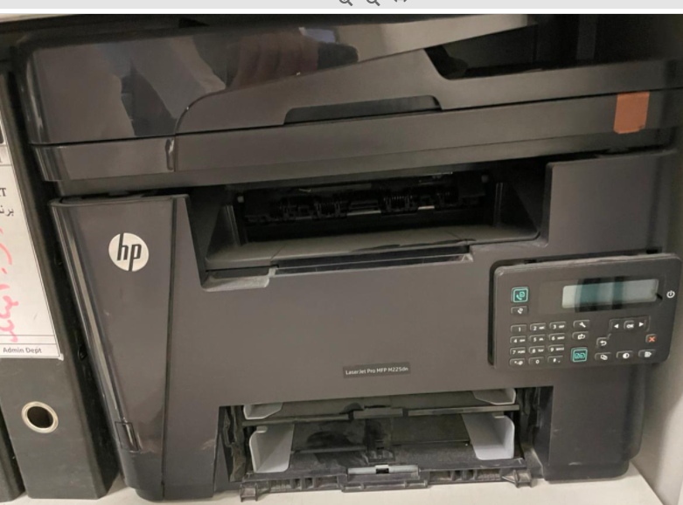

**Reasons:** HP LaserJet M225 issue is Fuser Unit due to the Old model

**Solution:**

HP LaserJet M225 Need to replace the OLD Fuser unit to new Fuser unit fixed the issue.

Printer total Cost is SAR 258.75

Quote is Attached DOC # 2