HP LaserJet 1300N Printer  (Retirement Report) |  | Badran ID | COMP-00007_1
 |  | Description | HP Printer 1300N
 |  | Location | HEAD OFFICE
 |  | Department | ACCOUNTS
 |  | Custodian | J001-35 – SAM AYTONA REYES
Material Picture | 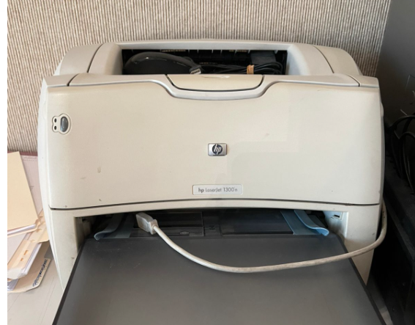
Symptoms | Below pictured HP LaserJet 1300N printer is very Old .
Reasons | This Printer is very old and Damage cannot be repaired.
Solution | Material is Damage, and it to be retired

Prepared By | Confirmed By | Approved By
614  Mojahid Hussain | 610  Russel. M. Kamarudeen | 600  Abdulrahman Y. Alshaikh

