**Maged mahmoud mostafa**

**Address:** **Egypt, Benha.** 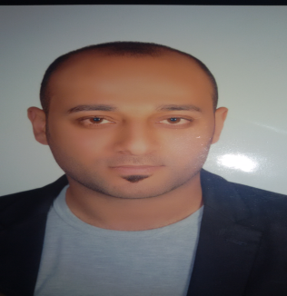

**Mobile**: **500594309**

**E-mail**: [***harfosh73@gmail.com***](mailto:harfosh73@gmail.com)

**_____________________________________________________________________________________**

**Objective**

Seeking an existing career opportunity with a reputable company where my educational skills and knowledge may be applied and utilized.

**Skills**

**Language:** Arabic: Mother Tongue

English: good. Writing, speaking and Reading

**Computer Skills:** Good uses of Microsoft Office "Word, Excel, Access, PowerPoint , also i am a very good user of internet navigation, Microsoft Project.

**Critical Attributes:** Strong Business acumen and sound understanding of various cultures. Extrovert willingness to listen, understand and offer solutions. Excellent in communications skills in Arabic, English & Computer literate.

**Education**

2007-2011: Bachelor degree in Management Business Administration From Elfraana Academy, Cairo, Egypt.

**Work Experience**

**2011 -2013:**

Domty company, Cairo, Egypt:

Sales man .

**2013 -2015:**

Domty company, Cairo, Egypt:

* Sales super visor.

**2015-2016**

Elfahed company, Cairo, Egypt:

* Manager k account

**2016 – 2017**

Emas international company, Saudi Arabia.

* Sales man

**2017-2019**

Dafa company, Saudi Arabia.

* Sales man

**Interests**

Driving, Sports, Listening to Music, Internet , Computer and Reading

**Personal Information**

Date of Birth : 28-8-1988

Nationality: Egyptian

Marital Status : married

**References**

Delivered Upon request