IMRAN MUHAMMED AKHTHAR 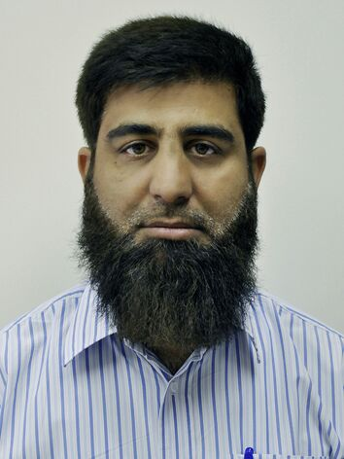
Mobile No.: +966-0500-049-196
Email Add: imranchohan@gmail.com
Current Location: Riyadh, Saudi Arabia

OBJECTIVE: To pursue a challenging position in a professional managed organization with potential opportunity to contribute to its growth and enhance my skills, moral, intellectual, and sociological.

PERSONAL DATA
Age: | 49
Date of Birth: | September 26, 1973
Gender: | Male
Civil Status:  Iqama Status:  Driving License: | Married  Transferable  Holder
Nationality: | Pakistani
Religion: | Islam

WORK EXPERIENCE
I have been working for 15 years.
1. | Position: | Liaison officer
 | Duration: | 2007 – up to present
 | Company: | AL DAFFAH COMPANY
 | Company Industry: | Sales /Trade / Rental / Real Estate
 | Location | Riyadh, Saudi Arabia
 | Department: | Marketing And Advertising
 | Job Description: | 1. Managing daily purchasing activities, supervising staff, and allocating tasks.  2. Developing and implementing purchasing strategies.  3. Managing supplier relations and negotiating contracts, prices, timelines, etc.  4. Maintaining the supplier database, purchase records, and related documentation.  5. Coordinating with inventory control to determine and manage inventory needs.  6. Managing the maintenance of office/manufacturing equipment and machinery.  7. Ensuring that all procured items meet the required quality standards and specifications.  8. Preparing cost estimates and managing budgets.  9. Working to improve purchasing systems and processes.
2. | Position: | HR/Admin Personnel
 | Duration: | 2005-2007
 | Company: | AL DAFFAH COMPANY
 | Company Industry: | Sales /Trade / Rental / Real Estate
 | Location | Riyadh, Saudi Arabia
 | Department: | HR/ADMINISTRATION
 | Job Description:
3. | Position: | Cashier
 | Duration: | 2004-2007
 | Company: | AL DAFFAH COMPANY
 | Company Industry: | Sales /Trade / Rental / Real Estate
 | Location | Riyadh, Saudi Arabia
 | Department: | Sales Department

EDUCATION
 | Highest Education Place
1992 Federal Board ISB:  1994 Federal Board ISB: | Higher Secondary School Certificate Riyadh, KSA  Secondary School Certificate Riyadh, KSA

SKILLS
 | Skill |  | Remarks
 | 1. Computer literate, can speak, read and write Urdu, English and Arabic well, hardworking, has an initiative on work, public relation and can work under pressure.  2. Know how to drive and familiar to all places here in Riyadh |  | Hope every employer that read my resume will impress to my file. Thanks and ALLAH yubarik fiyk.

TRAININGS/SEMINARS/CERTIFICATE
Date | Topic/Course Title Place
2004(6 months)  2005(3 months) | Computer Short Courses Ace Computers-Rawalpindi, Pakistan  Auto Cad Ace Computers-Rawalpindi, Pakistan
2005(3 months)  2005(6 months) | Micro Station Ace Computers-Rawalpindi, Pakistan  Drafting Ace Computers-Rawalpindi, Pakistan

LANGUAGES SPOKEN
 | Language | Proficiency Level  (5=Excellent; 1=Poor)
1. | Urdu | 5
2. | English | 4
3. | ARABIC | 4

REFERENCES
Abdul Rahman Alshaikh
0568979797

I hereby certify that the above information are true and correct with the best of my knowledge.
end

In the name of Allah, Most Gracious, Most Merciful

Dated: 06/02/2022

To: Human Resource Department

Dear Sir:
I take the opportunity to introduce myself as young energetic and self-motivated. Living here in Saudi Arabia for 40 years. With transferable iqama and has an interest to work with your establishment in the area of AutoCAD and Micro Station design, Cashiering, Administration especially in Sales or Purchasing as I have more than 15 total numbers of years of experienced.
I assure you of my best effort to be found myself in the area of satisfactory to my seniors and management and fulfill all my duties punctually and sincerely.
Please find an attached profile of my detail carrier and consider the same against your current vacancies if there is any available. I believe that the enclosed profile may not sufficient to explore all my skills and talent, so I emit a chance for the interview to prove my skills and ability.
With best regards,

Imran Muhammed Akhtar
0500049196

