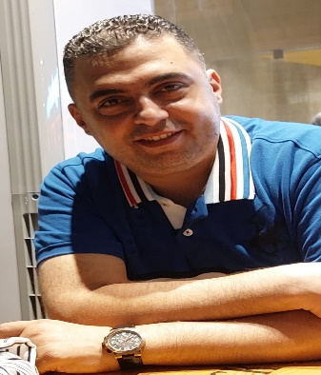

Ayman fekry alnahas

Address: EGYPT- alsaba hospital st asafra Alexandria

Egyptian Number: +201200035868

E-mail: afekry806@gmail.com

|  |  |  |  |
| --- | --- | --- | --- |
| **objective** | | | |
|  | | Seeking a challenging position where my theoretical and practical experience could be developed and enhanced in a prestigious organization.  Seeking a job at a reputable company where my background and experience can be well utilized |
| **education** | | | |
|  | | 2006- 2003 Alex University ALEX, Egypt  BA of.   * Bachelor of Computer since. * Grade: Good. |
| **skills** | | | |
|  | | ***Computer Skills:***   * Very Good Knowledge of MS Windows, Office, MS Project and Internet.  1. ***Language Skills:***  * Native language Arabic. * V Good command of both written and spoken English. |
|  | | | |
|  | | | |
|  | **(job EXPERIENCE)**   * **Alexandria sales manager at Heinz company from may 2022 till now** * **Riyadh branch manager at " Ajlanbros Company “** (APR 2018- Apr 2022) * **Reporting to sales Director**   ***Responsibilities***   * Managing organizational sales by developing a business plan that covers sales, revenue and expense controls. * Manage business about 40 M SAR per year. * Manage team ( 9 presell – 2 drivers ) * Meeting planned sales goals. * Setting individual sales targets with the sales team. * Tracking sales goals and reporting results. * Overseeing the activities and performance of the sales team. * Training sales reps. * Developing sales team through motivation, counseling and product knowledge education. * Promoting the organization and products. * Monitoring and evaluating the activities and products of competitions. * Visit key costumers to strengthen relations with them. * (AUG.2015- JUL. 2018) – Alexandria Sales super visor at " **Speed ahmed Hassan Egypt** * (Mar.2009-May. 2015) – territory Sales Supervisor at " **PEPSI Cola Saudi Arabia.** * (mar. 2007- JAN.2009) – Sales Supervisor at **" JEMMA mineral water UEA .** * (Feb. 2006 - Feb.2007) – Sales Supervisor at **" NAHL mineral water Egypt .** * (Mar. 2004- DEC.2005) – Sales rep at **" Nestle mineral water ksa .** | |
| **Trainings**     * Enhanced Presentation & project development skills * Preparing leaders (Pepsi) * (Jun 2009) Basic sales and marketing in (Pepsi academy) * Time management and coaching course (AJLANBROS) | | | |
|  | | |  |  |  | | --- | --- | --- | | **Personal Information** | | | |  | Date of Birth: 01/01/1983  Marital Status: Married |  * + - Egyptian Driving valid license. Yes (private)     - Saudi Driving valid license. Yes (private)     - Uae Driving license. Yes (private) |

.