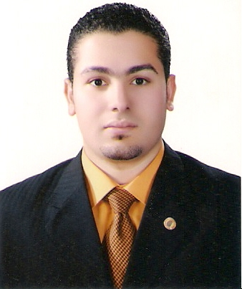
Curriculum Vitae

Personal Information’s:

Name: EIhab Mohamed Mahmud Al raey
Marital Status: Single
Birth Date: 14-10-1987
Place of Birth: Shobrakas-Elsanta-Gharbia
Nationality: Egyptian
Military service: Exemption
---------------------------------------------------------------------------------------
Educational Qualifications:
-Tanta University.
-Bachelor of Physical Education
-Specialization: Administration (marketing- media sport).
-Graduated year: 2009
-Grade: very good.
------------------------------------------------------------------------------------------------------------------
Experience Acquired:
1-Working as a sales representative in Ibn Sina Pharma Pharmaceuticals from the period 2009-2010 .
2-Work in Mars Global Inc. ( Galaxy ) salesman from the period 2010-2012.
3-work in the Arabian trading supplies- naghi group ( marketing specialist ) in the Department of Food ( Holstein - California Garden - Caprisun - Power Horse - Extra ) from the period 2012 to date.
4- Upgrade to function account representative at department food service These include restaurants, catering companies, hotels and everything related to food.
-----------------------------------------------------------------------------------------------------------------
Personal Skills:
Good user of Microsoft Office and Internet
Good communication skills and a work ethic and ability to learn quickly new
Viability of the good work under pressure and within a team initiative
Ability to deal with all levels of management
The ability to coordinate dealings with organizations and various government agencies.
------------------------------------------------------------------------------------------------------------------
Personal interest And Hobbies:
1) Playing football.-swimming and others sports.
2) Reading stories and news papers.
------------------------------------------------------------------------------------------------------------------
Contacts:
Mobile No:00966591272728
E-Mail: ehabelraey8@gmail.com
------------------------------------------------------------------------------------------------------------------

Great honor to be a member in your teamwork

